Title:- Laptop Specifications Data Analysis Report

Student Name: Yeswanth Ponnuru

Student ID: 23076804

Git Hub Link: https://github.com/yeswanth2727/LaptopSpecifications-Data-Analysis-Report

Abstract:

This report analyzes a dataset of 1,275 laptops from multiple brands, examining key attributes like screen size, RAM, weight, price, screen resolution, CPU speed, storage, and features such as touchscreen capability and display type. Using descriptive statistics and exploratory data analysis (EDA), we uncover trends in average values, ranges, and distributions. The report concludes with findings and suggests avenues for further analysis to deepen understanding of trends in laptop specs and pricing.

1. Introduction:

The laptop market provides a wide range of options, from basic to highperformance models. This dataset includes 23 attributes, such as product specifications and prices in euros, offering insights into common features and pricing factors. Analyzing this data helps consumers make informed choices and aids manufacturers in identifying popular features and market gaps.

1. Objective:

The main objectives of this analysis are to summarize key laptop characteristics, explore how specifications influence price, and provide insights into current trends for consumers, manufacturers, and marketers.

1. Descriptive Statistics Report Summary Statistics for Numerical Variables:

The average laptop screen size is 15.02 inches, with models ranging from compact to larger sizes. RAM typically stands at 8 GB, though it varies between 2 and 64 GB. Laptops weigh around 2.04 kg, offering a balance of portability and performance. The average price is €1,134.97, with a wide range from budget to premium options. Full HD (1920 x 1080) is the most common screen resolution. CPU frequencies average 2.5 GHz, suitable for general tasks. Primary storage averages 444.52 GB, mostly SSD-based, while secondary storage is less common.

1. Exploratory Data Analysis (EDA)
2. Distribution of Laptop Types (Pie Chart)

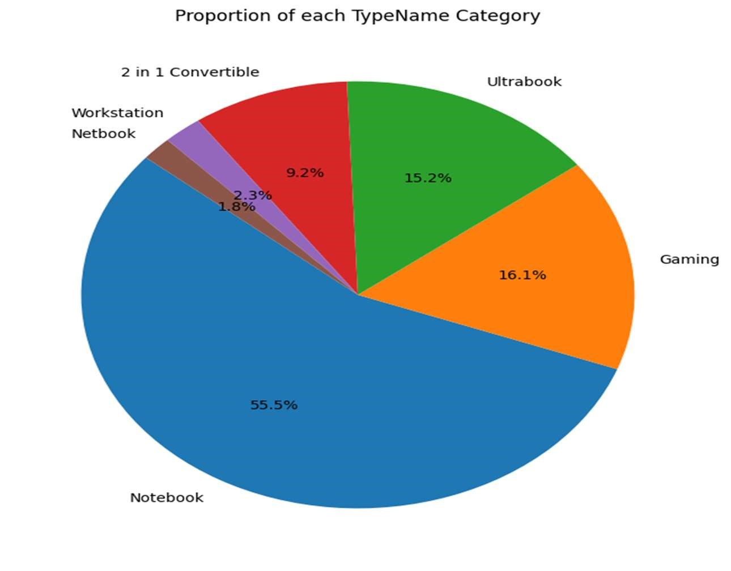

The pie chart illustrates the distribution of laptop types (TypeName) in the dataset, with notebooks making up the largest portion. Their popularity stems from their versatility, making them ideal for personal, educational, and professional use. Specialized categories, such as gaming laptops, ultrabooks, and workstations, are less frequent but still notable. Gaming laptops are designed for high-performance tasks, while ultrabooks focus on portability and battery life, catering to frequent travelers. Workstations are built for professionals requiring powerful processing capabilities. This distribution provides insights into consumer preferences and can inform further analysis of price, specifications, and performance across laptop types.

1. Price vs. Screen Size (Line Graph)

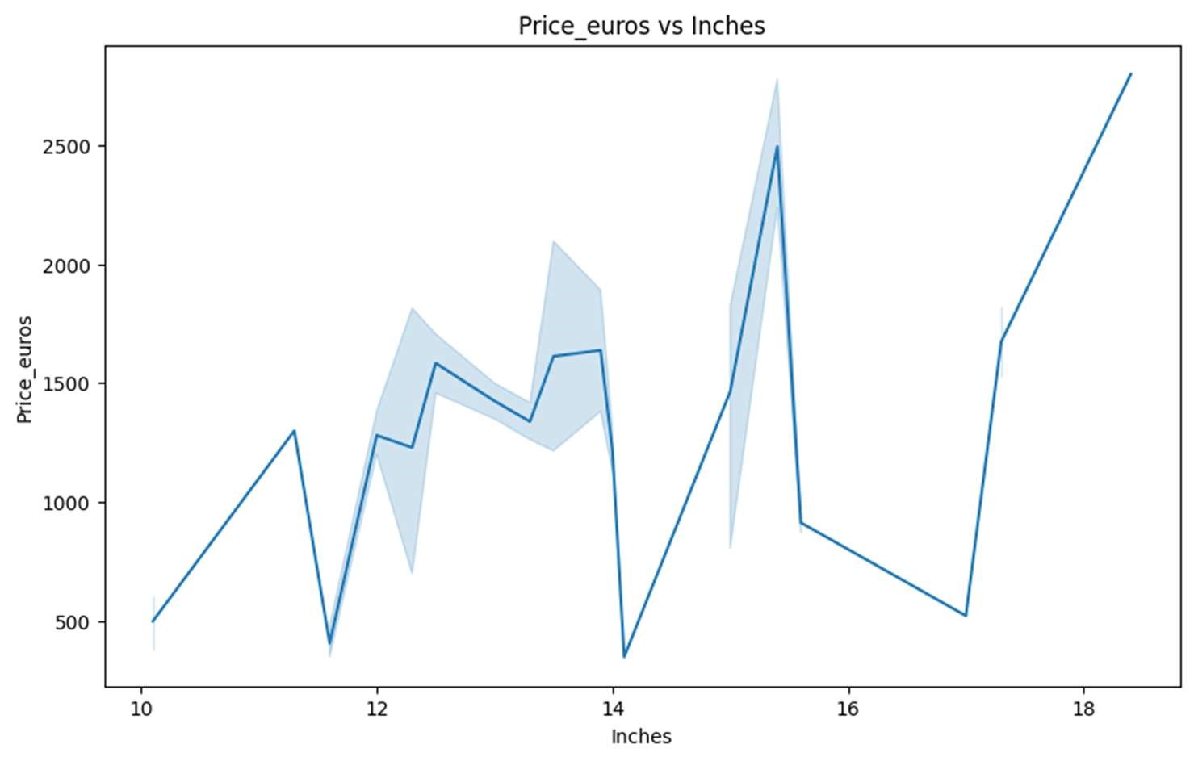

The line plot of screen size (Inches) versus price (Price_euros) shows a clear upward trend, with larger screen sizes generally linked to higher prices. This is due to factors like increased manufacturing costs, higher screen resolutions, and enhanced graphics features typically found in premium models. Larger screens often correlate with laptops designed for gaming, multimedia, or professional tasks, which include additional performance specifications. However, there is significant price variability within each screen size, indicating that other factors like RAM, CPU speed, brand, and design also influence the price. This suggests that screen size is not the sole determinant of laptop pricing..

1. Correlation Analysis (Heatmap)

The correlation heatmap reveals several key relationships between numeric features in the dataset. Screen width (ScreenW) and screen height (ScreenH) show a strong correlation, indicating most screens follow similar aspect ratios, like the common 1920x1080 resolution. Additionally, there is a positive correlation between RAM and price, with laptops offering more memory generally being priced higher, as they tend to support more demanding tasks. CPU frequency also has a moderate positive correlation with price, suggesting that faster processors are often found in more expensive models, although other factors likely contribute to the overall price as well.

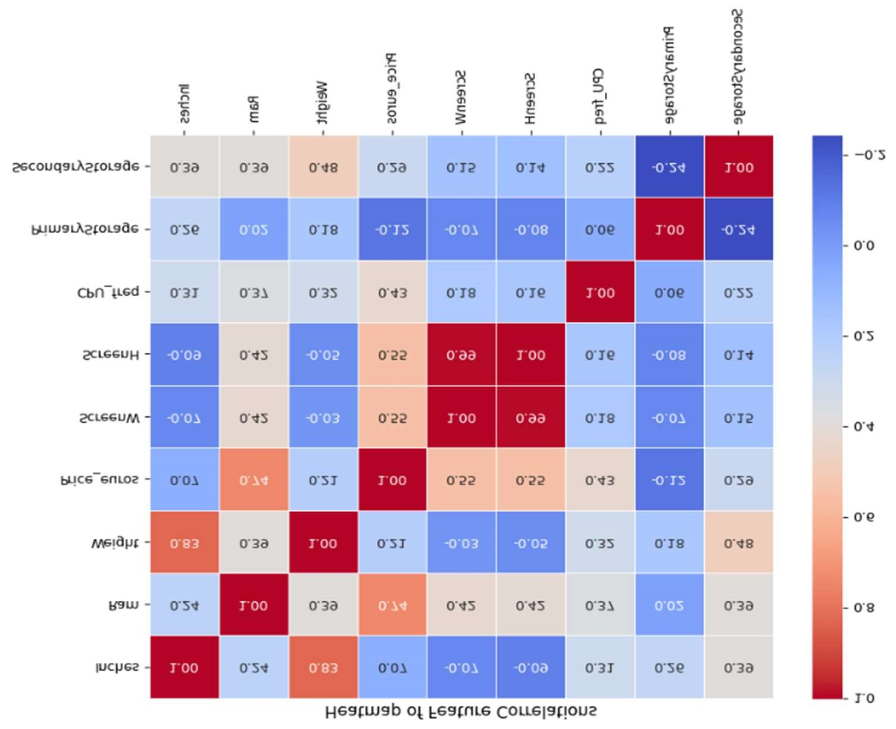

1. Conclusion:

The analysis reveals that mid-range specifications, such as 8GB RAM, 15.6-inch screens, and 256GB SSDs, are most common. Premium models with better displays, faster processors, and larger RAM command higher prices. SSDs are increasingly preferred over HDDs for primary storage due to their performance benefits.

1. Suggestions for Further Analysis:

Further analysis could involve examining trends in specifications and prices over time, clustering laptops to identify distinct groups or price segments, analyzing consumer reviews to assess perceived value, and developing predictive models to estimate prices based on key specifications.